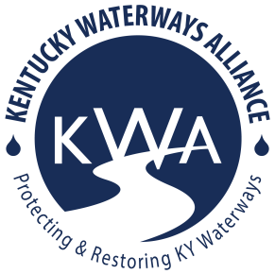
Kentucky Waterways Alliance
2024-2026 Watershed Grant Application

Thank you for your interest! Please fill out the following questions and information. Note the maximum word count for each question. Refer to the Request for Applications here: https://www.kwalliance.org/watershed-grants for more information or contact laura@kwalliance.org.

1. Grant Applicant

Contact Name:

Organization Name:

Is organization a 501c3? Yes/no:

If no, is applicant organization fiscally sponsored? Yes/no:

EIN number:

Address:

Contact phone:

Contact e-Mail Address:

Organization mission & brief history (300 words):

Partner organizations or agencies (name and contact information), if applicable (300 words):

2. Focus waterway

Name of major river basin (if known – see 7 major river basin map below or ask!):

Project location (name of stream, river or lake, etc):

(Please attach or include a map of the focus area, if possible.)

3. Describe project activities, roles of partners (if applicable), and timeframe for completion. Is this project part of a more comprehensive plan for improving the watershed? (500 word limit)

4. How will your project prevent or address nonpoint source pollution? What aspects of the watershed and its water quality do you plan to improve? (600 word limit)

6. Do you have any documentation of impacts on the water quality in project location (i.e. photographs, reports, stream sampling results, etc)? Send attachments if applicable. (400 word limit)

7. How does your project focus on environmental justice? KWA will utilize EPA’s EJScreen: Environmental Justice Screening & Mapping Tool when processing applicants. (300 word limit)

8. Grant request

Total amount requested (up to $4,000):

Detailed Budget for expenditure:

Line Item/description | Budget

Please e-mail your completed application to laura@kwalliance.org. Deadline to submit: February 29, 2024 at 11:59pm.

Contact Laura Gregory with questions about the application process or project requirements and opportunities:
Laura Gregory, Watershed Program Director
Kentucky Waterways Alliance
E-Mail: laura@kwalliance.org

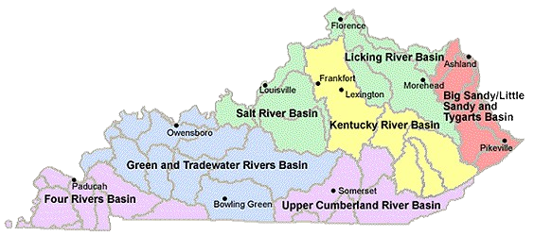

This work was funded in part by a grant from the U.S. Environmental Protection Agency under §319(h) of the Clean Water Act.
