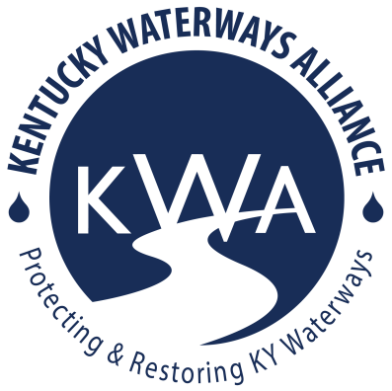
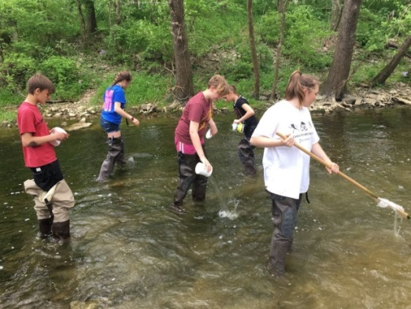
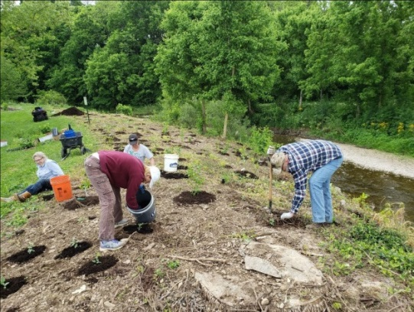
Request for Applications
2024-2026 Watershed Grants
Kentucky Waterways Alliance (KWA) is pleased to announce our 2024-2026 watershed grants. This pilot program will provide seed grant funding assistance in all of Kentucky’s seven major river basins to organizations that are interested in doing their part to protect and restore their rivers, streams, and watersheds. Grant funding will be awarded to at least one project per river basin.
Projects must address nonpoint source (NPS) pollution, which includes pollution that cannot be directly attributed to a distinct source. NPS pollution is unlike Point Source Pollution, which occurs when pollutants are discharged from distinct, confined conveyances, such as a pipe, well or even a boat. NPS pollution is caused by rainfall or snowmelt moving over and through the ground. As the runoff moves, it picks up and carries away natural and human-made pollutants, finally depositing them into lakes, rivers, wetlands, coastal waters and ground waters (EPA). Some NPS pollutants include oil and gas on roads and driveways, fertilizers on lawns, pesticides on food crops, soap from car washes, and dirt from construction sites. NPS pollution can also come from cattle in streams, failing septic systems, or collapsing stream banks. As these different pollutants build up in the water, our water quality declines. A decline in water quality is bad not only for the plants and animals that live in the water, but also for our drinking water.
KWA grant funding can support stream cleanups, tree plantings, educational signage, water festivals, water quality sampling, rain gardens, rain barrels, and many more beneficial activities and best management practices. These are examples but by no means an exhaustive list.
KWA is committed to supporting and empowering underserved communities and will utilize the EPA EJ screening tool in the grant award selection process. Environmental justice (EJ) is the fair treatment and meaningful involvement of all people regardless of race, color, national origin, or income with respect to the development, implementation and enforcement of environmental laws, regulations and policies. *To learn more about the EPA’s environmental justice information, see this link.
If you are interested in addressing NPS Pollution in your area, please consider applying for this grant opportunity:
- ALL communities encouraged to apply!
- Eligible to any organization (nonprofit, alliance, fiscally sponsored, etc) with an NPS pollution-related project
- Funding amounts up to $4,000 per project – In some circumstances KWA may only award partial funding.
- Requests must align with the EPA’s guidelines that prohibit the following ineligible expenses:
  - Developing or purchasing promotional materials (t-shirts, bumper stickers, mugs, etc)
  - Food, beverage, alcohol
  - Entertainment at an event (bounce house, bands/music, etc)
  - Research, faculty salaries, and development of college credit courses or tuition
  - See more info at Section 319 Resources – General Guidance – 319 Ineligible Expenses
- 50% of funds will be distributed upon project award agreement, 25% at mid-project report and 25% upon final report
- Funds can be applied to approved project expenses incurred during project timeline from May 1, 2024 until March 31, 2026
- Project completion timeframe
  - 1/30/24 grant applications available
  - 2/8/24 3pm EST optional virtual grant workshop – sign up here
  - 2/13/24 7pm EST optional virtual grant workshop – sign up here
  - 2/29/24 grant applications due to Laura@kwalliance.org by 11:59pm
  - April 2024 grant awards announced
  - May 2024 awards distribution
  - March 5, 2025 – mid project report
  - Final project report due one month after project completion, and no later than April 30, 2026
  - Please note: projects must meet or be earlier than these deadlines
KWA encourages (not required) all applicants and awarded organizations to attend the Kentucky Watershed Network Annual Collaborative Summit to share your successes, struggles, ideas, and learn with and from watershed stewards from across the state. The Summit is tentatively scheduled for 8/25/24-8/26/24 in the Morehead, KY area and will be at a similar time in 2025. You can write a travel stipend into your grant request!
Grant application can be found by visiting: https://www.kwalliance.org/watershed-grants. Applicants are strongly encouraged to contact Laura Gregory to discuss your project or you can join KWA’s optional virtual seed grant workshop.
Questions? Please contact Laura Gregory, Kentucky Waterways Alliance’s Watershed Program Director, at laura@kwalliance.org
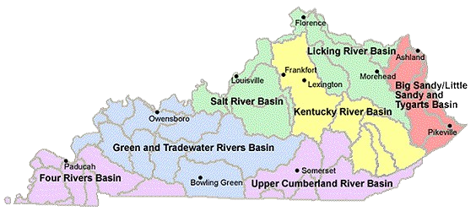

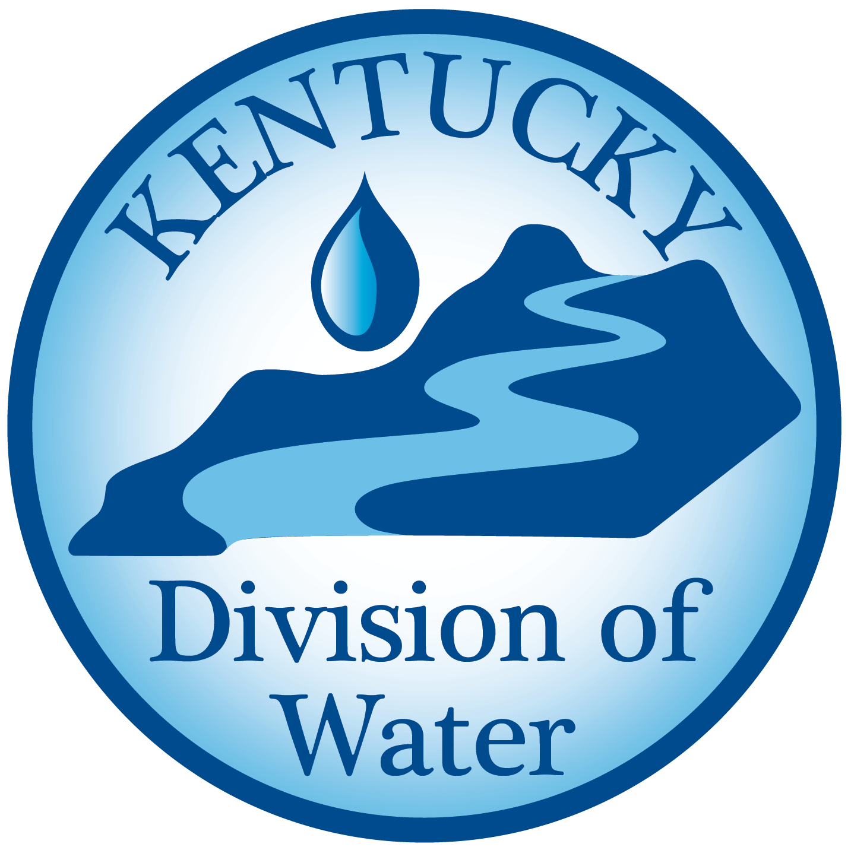This work was funded in part by a grant from the U.S. Environmental Protection Agency under §319(h) of the Clean Water Act.

